Responsive Design starts with Controlling the Viewport

2 ways to do that.

1. Meta Viewport tag

<head>

<meta name=”viewport” content=”width=device-width”>

</head>

1. @Viewport CSS Rule - Should place before any media queries, maybe even 1st in css

/* CSS Document */

@viewport {

width: device-width;

}

****Not sure why, but if I wanted to disable zoom, or set a limit on my app for zooming. I can.

For a complete list of what I can do, go to <http://goo.gl/Rxfdi>

Near Universal support for the Meta name viewport setting….. probably stick with this moving forward.

Reference Pixel – A unit of measurement that establishes an optical standard for the length of a pixel. It gives you a way to consistently set the size of elements that is independent.

Really understand Media Queries

Media Queries – Media Queries were created to allow designers to extend the media declarations to include various media properties when filtering style application.

Media Features to test with- width, height, device-width, device-height, orientation, aspect-ratio, device-aspect ratio, color, color index, monochrome, resolution, scan, grid

Media Queries can be accessed/linked at the top with the external CSS in the header.

W3.org/TR/css3-mediaquires

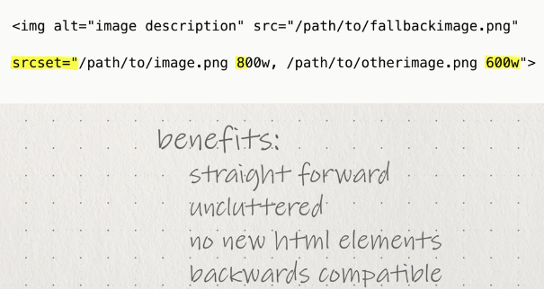

Common Concepts – Responsive Design

1. Mobile Viewports
2. Understanding the screen density
3. Using media queries
4. Using breakpoints
5. Using fluid grids
6. Making images responsive
7. Building responsive forms
8. Content Strategy –
9. Start by Content Inventory.
   1. New products
   2. Images of products
   3. Contact information
   4. Order status
10. Determining your Breakpoints
11. Determine what your smallest screen size (*480 px) and the largest screen (*1200 px) size
12. Once you have both of these numbers, divide and add 2 more breakpoints
13. ***Tweakpoints. Smaller break points for specific items (like Navigation)

Content strategy refers to the practice of identifying, organizing and managing a site’s content.

CMS = Content Management Systems.

Content Strategy refers to: 1. Identifying content 2. Organizing Content. 3. Managing Content.

Goals: Emphasize important content, make relationships clear, make it accessible on small screens

Start with your content –

How does the page content relate to each other?

Given the goals of the page, which content is the most important?

Is this repeating content across the site or is it specific to just this page?

How many different categories of content do you have, and how are they being used throughout the site?

Design diagrams of your sites content, which can help visualize relationships, categorize it, and establish hierarchies.

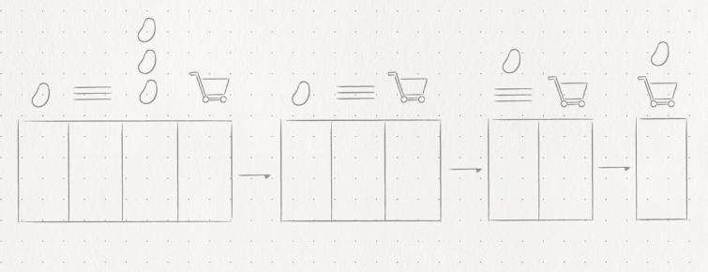

Start with the smallest screensize and then use the page inventory to determine which content should display first and how users are likely to interact with it in related content.

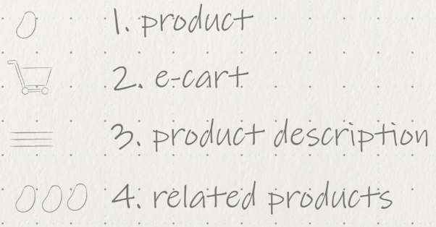

* + 1. If I have trouble, imagine I have a phone screen and I can only show one piece of content, what would it be? And then 2? And then 3 and eventually 4. Add content and how people would interact with them.

Wireframe this and do the same for the wider screen sizes.

WHAT IS MICROFORMATS? [www.microformats.org](http://www.microformats.org) [www.schema.org](http://www.schema.org) [www.w3.org/TR/microdata](http://www.w3.org/TR/microdata)

Scripting – Extraneous markup AND slow page loads

W3c Flexible Box Model and CSS Grid Template Layout Module

First thing to test in responsive design

* Media Queries. And whether or not they are hitting the right breakpoints. <http://goo.gl/Pd9T2>
* Responsinator.com – See URLs at preset breakpoints
* Responsive.is – see urls and click on the icons of the item you want to see it through
* Screenqueri.es – see URLs with rendering, pixel layout, mobile phone choice
* <http://goo.gl/qkq1F> - What resources are slowing my site down
* Testiphone.com
* <http://goo.gl/DMLHk> - guide to mobile emulators
* <http://goo.gl/GB2WY> - mobile remote debugging
* <Http://goo.gl/UrcSp> - webkit remote debugging

Fluid Grid Framework – 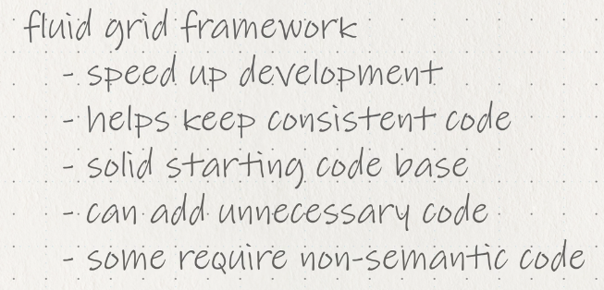

Grid Only Option – Golden Grid System – a folding grid for responsive design <http://goldengridsystem.com> – 18 column grid desktop. 8 grid for tablet. 4 for mobile.

Simple Grid – <http://simplegrid.info> – 4 pre-build breakpoints for multiple diff screen sizes

Columnal – [www.columnal.com](http://www.columnal.com) - not really a fan but check it out

Responsivegridsystem.com – very flexible responsive grid that allows you to decide how many breakpoints, columns, etc

Gridsetapp.com , foundation.zurb.com , bootstrap by twitter, html5boilerplate.com/mobile

Getskeleton.com – lightweight, fluid grid, basic typography controls, styling.

<http://goo.gl/VwZtu> - Responsive Web Design Sketch Sheets

github.com/filamentgroup/southstreet

<http://filamentgroup.com/lab> - Read and check on this

[www.lukew.com](http://www.lukew.com) – author of mobile first. Maybe best resource for designing for mobile context

unstoppablerobotninja.com

bradfrostweb.com